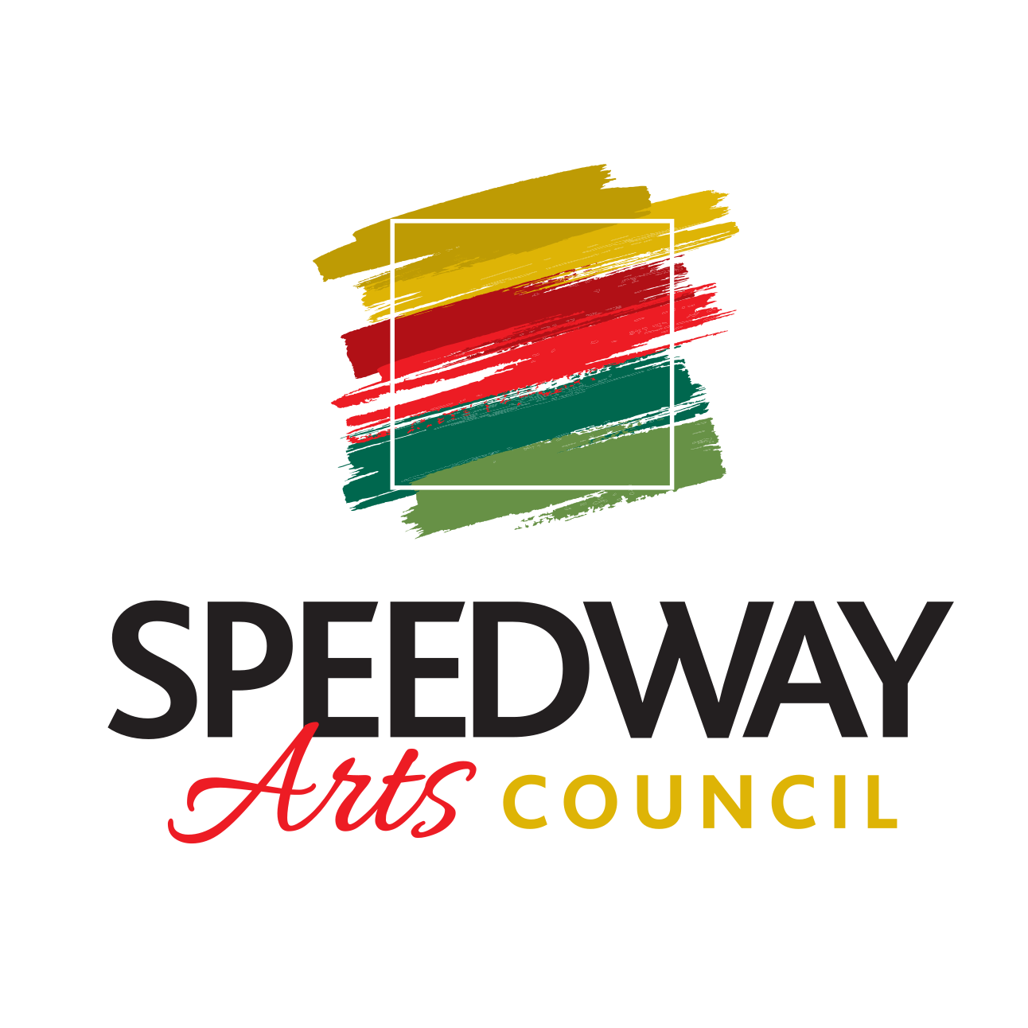

Meeting Agenda
For Tuesday, September 21st, 2022

Active Projects
SMC Mosaic
- Software choice
- Community engagement
Community Mural
- Clear coat -
  - Date to complete
  - Professional Options
  - Plaque with logos
Salt Barn Mural
- Discuss final design concept
- Identify date of installation
- Community engagement piece
Historical/Interactive Murals on Main
- Budget number included-$10,000 including paint budget
- Building owners are considering prepping and priming walls
- Community committee to filter out top 10 artists
Holiday Pop-Up Shop
- Need to confirm Wilcox cafe with Mel
- Dates
- Notify artists and put out call to artists
Historical Photo Exhibit in Municipal Center
- Cost of prints
- Cost of frames
- Partnering with Speedway Historical Society
- Design ideas

New Projects/Ideas to Discuss
Cut out race cars for light posts-Vince noblet suggestion

