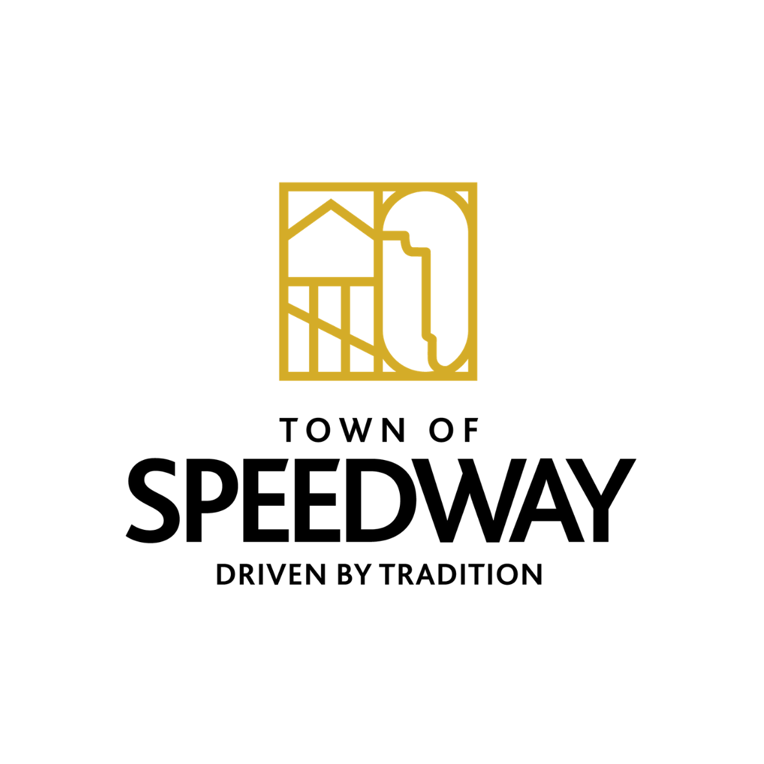
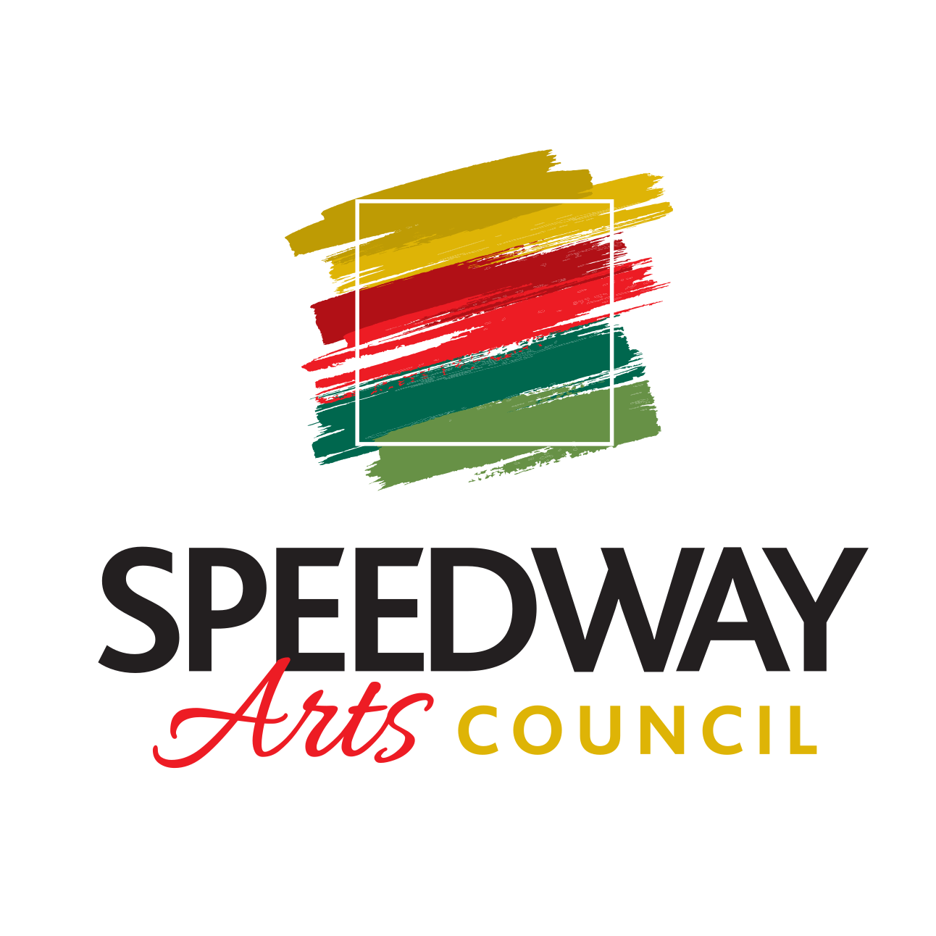
Town of Speedway
Arts Council

Meeting on 7/14/2022
In Attendance:
Katie Maiers, Bruce Levy, Chris Nusbaum, Cheryl McElroy

Active Projects

SMC Mural
- Proposal/Update: Bruce and Chris
  - Photo Storage
  - Forms for public to opt in to arts using photos
- Discussion:
  - Online submissions/form to opt in and submit pics and give rights for Arts council to use photos
  - IMS Permission to use photos
- Decisions: N/A
- Next Steps:
  - Katie to reach out to IMS Photo Lab, Bruce to create online submission platform

Community Mural
- Proposal/Update: Katie
  - 10 gallons of clear coat from PPG was bad and we could not use
- Discussion:
  - We need to apply Rain Guard product K7000
    - Cost: $188 per 5 gallons
- Decisions:
  - Chris made motion for a $500 budget to purchase RainGuard product and rolling supplies to apply product/Bruce 2nd motion/ Vote passed unanimously
- Next Steps:??
  - Pick up RainGuard (Katie)/identify date for application

Holiday Pop-Up Shop
- Proposal/Update: Group
  - Figure out location
  - Arts Council needs to purchase grid walls and find a location to store them
- Discussion:
  - Foyt Wine Vault, Wilcox
    - Wilcox would be the better location
    - Could the grid walls be stored at Wilcox or SMC?
- Decisions: N/A
- Next Steps:
  - Chris to research grid wall prices
  - Katie to reach out to Mel and Steve Wilcox for use of space

Steampunk Artist Zoom Meeting
- Proposal/Update:
  - Artist would like to discuss his art included in town redevelopment
- Discussion:
  - Meeting on Tuesday, Aug 9th at 5pm
  - Jennifer Miller (SRC) and Todd Cook (economic development director) invited
Interactive Murals on Main
- Proposal/Update:
  - Arts Council received grant for $10K to install 2 murals on Charlie Browns and City Dogs/Voom Room Building
- Discussion:
  - Call to action to go out in late July and be open ended until artist is selected
  - Budget for artist compensation is $8,000
    - Arts Council will be prepared to cover additional funding if needed to complete these murals

