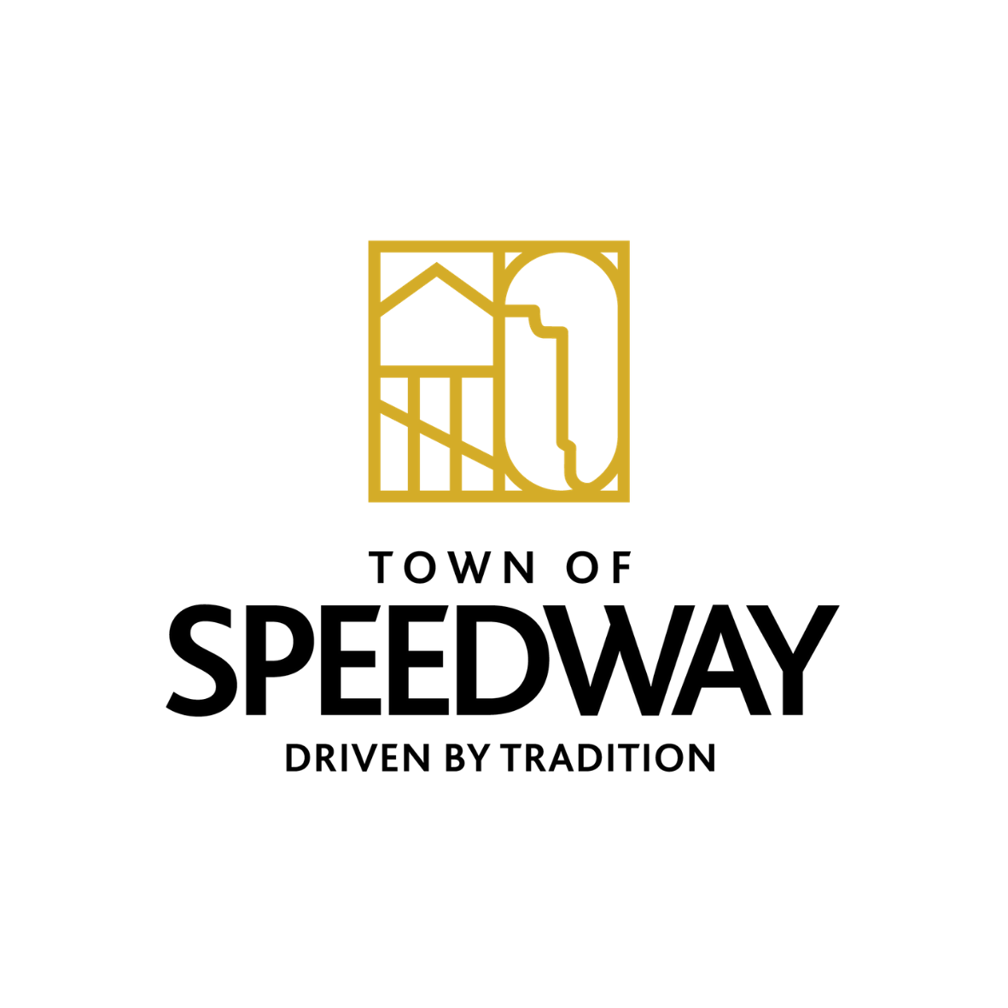
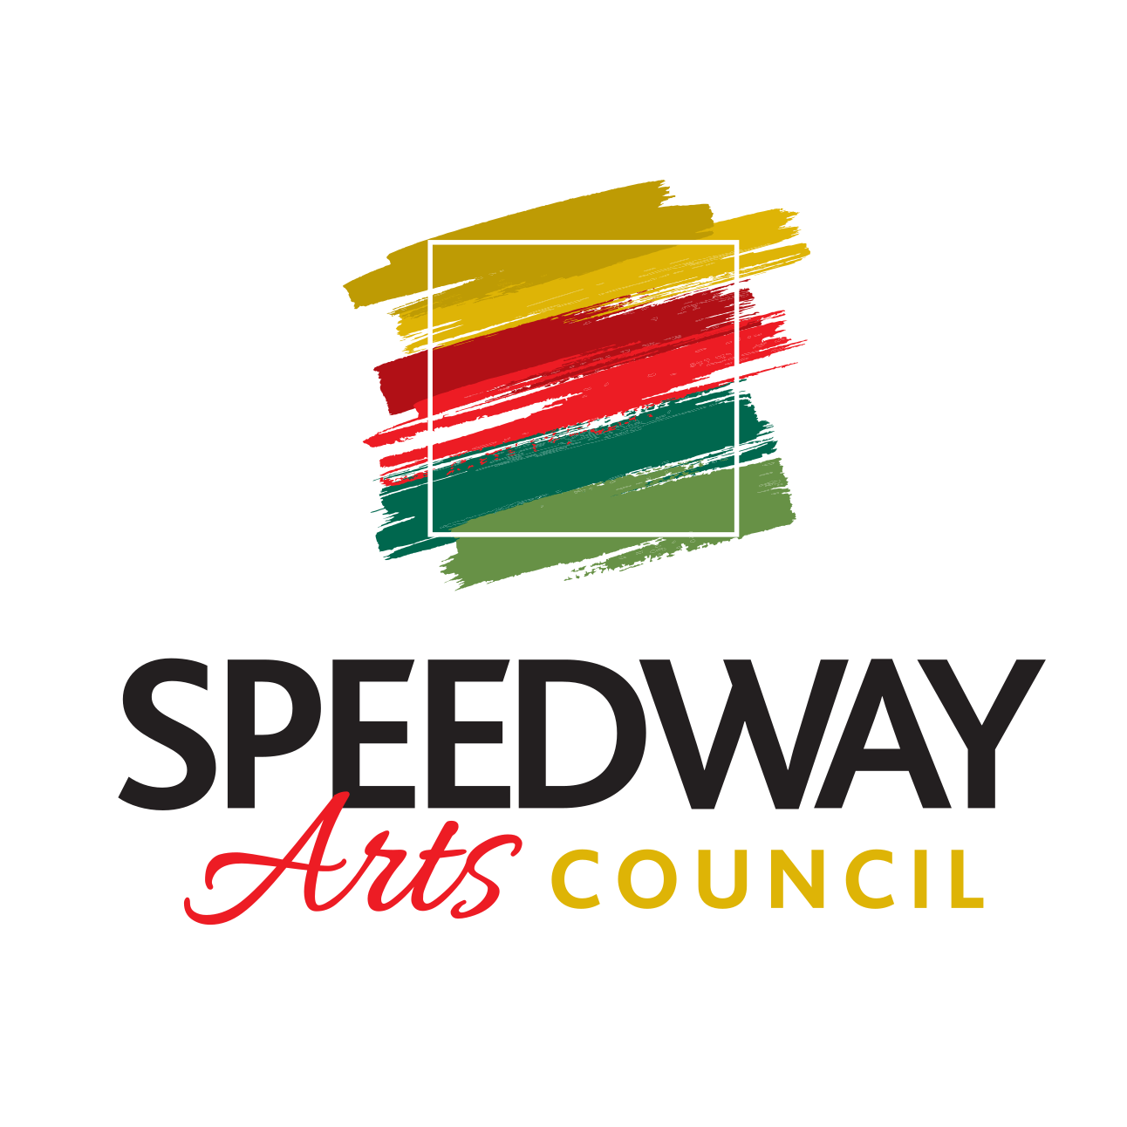
Town of Speedway
Arts Council

Meeting on September 28th, 2021

ATTENDANCE

Board Members: Katie Maiers, Chris Nusbaum, Laura Londry, Bruce Levy, John Miller
Town Officials: None
Guests:

MINUTES
- Call Meeting to order:
- Approval of Previous Meeting Minutes (send to Communication Director):
- Reports of Officers:
  - President-
  - Vice President-
  - Secretary-
  - Community Liaison-
  - Communications Director-
- Guest:
  - Reports of Speedway Arts Corporation Non-Profit 501-(c)(3):
  - Financial Report-
    - Ending account balance from:
    - Paypal account-
- Items to vote on:
  - 1. Mission/Vision Statement changes:
    - Speedway Arts Council Revised Mission/Vision
      - Mission: The members and board of the Speedway Arts Council believe that art is an essential keystone in creating a vibrant and thriving community for our residents, workforce, and visitors. We exist to promote, develop, and encourage arts organizations, artists, and participation in the arts in our town; while striving to make art accessible, experiential, and engaging
      - Vision: The vision of the Speedway Arts Council is to enlighten and transform the lives and experiences of our residents, workforce and visitors, and to leave the Town of Speedway, IN better than we found it for those who will follow us.
Previous Speedway Arts Council Mission: The Speedway Arts Advisory Council mission is to stimulate appreciation of the arts in all forms. To enrich the cultural lives of Speedway residents and guests; encouraging a focused vision of art and culture throughout the community.

Previous vision:Fostering community through public art Speedway residents thrive from public belief in, and support for creativity and the arts. To that end, we envision a town where:
• the lives of all residents are enriched by access to and participation in a diverse spectrum of arts and cultural experiences;
• the arts are woven into the fabric of daily life—promoting civic engagement, encouraging collective problem solving and building bridges across cultures;
• the arts enjoy strong, sustained public support;
• the arts ecosystem reflects contributions from all of our local diverse populations;
• our students are provided with quality arts education so that they can reach their full potential, including advanced education;
• streets, neighborhoods, and communities are revitalized, enriched and enlivened by art and culture;
• creative industries are recognized as crucial to the economy;
• public and private resources for the arts increase and are sustained to more effectively serve the people of Speedway;
• Local artistic contributions mark the long-term legacy of the town;
• the Speedway Arts Council is recognized as an innovative and cutting-edge agency and known as a regional leader among state arts agencies for its exemplary work on behalf of all residents; and
• The Speedway Arts Council is a source for policy development and builds a strong foundation for the arts in our town, city, and state.
2. Nonprofit Board Appointments

- Ongoing Projects:

  - 1. SMC Mural
    - Budget for mural-potential match from SRC of $2500
    - Proposals from Artists:
      - Travis Neal
      - Jonathan Mummert
      - Michael Martin
      - Alex Wakefiled
  - 2. SMC Lower Level Gallery- Create a museum of Speedway history with items on loan from various residents/businesses
      - Interest from Darrren Jacks: owns Ron Burton house and artwork, racing memorabilia-

3. Order business cards for Arts Council members
    - Moo.com-
- New Projects to consider:

1. Christmas Pop-Up Shop on Main St
  - 2. May 2022 Pop-Up at Wilcox
  - 3. Speedway Art Trail
  - 4. Murals on Main
  - 5. IRMA Plaques Placement- Bruce Levy
  - 6. Main Street Walk-of-Fame

- Good to the Order:
- Announcements:
- Tasks
- Adjournment:
- Executive session
- Next meeting:

