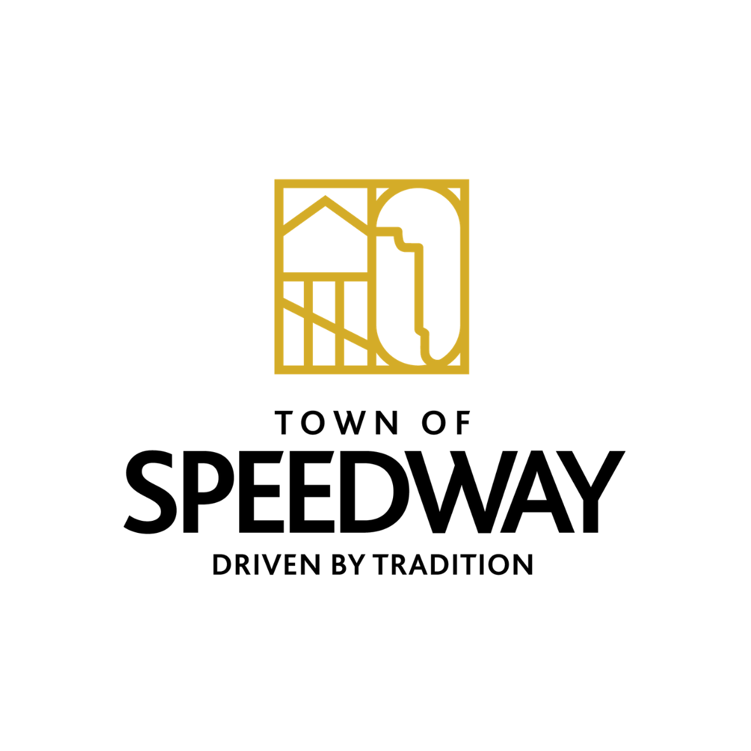
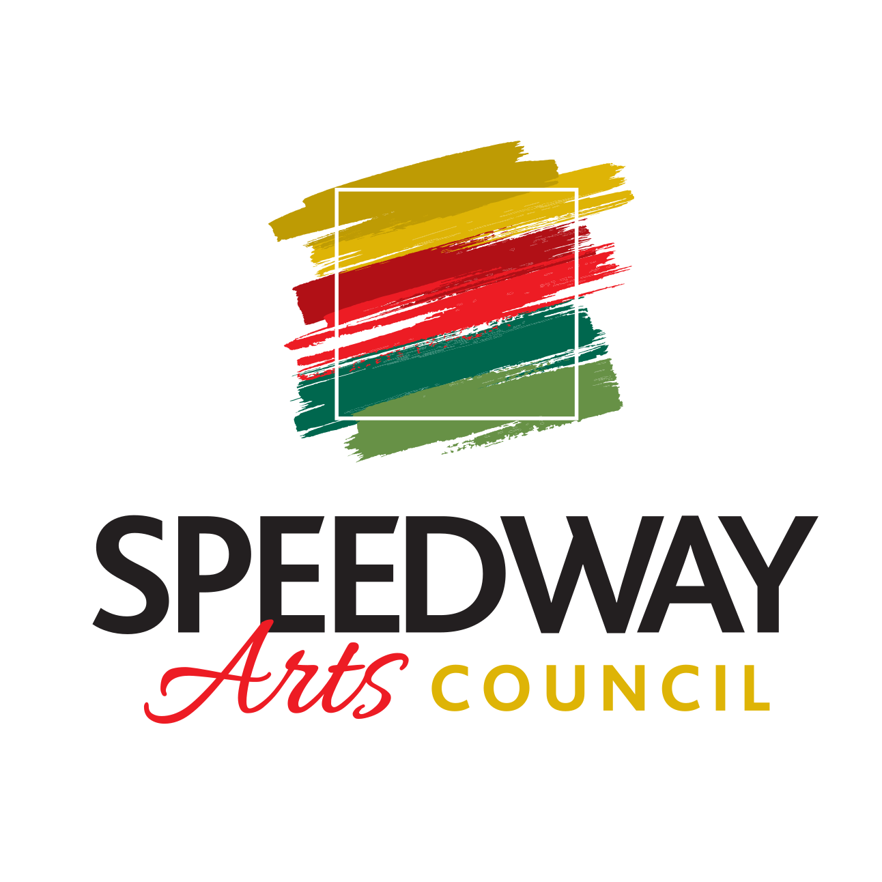
Town of Speedway
Arts Council

Meeting on October 28th, 2021

ATTENDANCE

Board Members: Katie Maiers, Chris Nusbaum, Laura Londry, Bruce Levy, John Miller
Town Officials:
Guests: Annetta Gholdson

MINUTES
- Call Meeting to order: 6:37pm
- Approval of Previous Meeting Minutes (send to Communication Director):
- Reports of Officers:
  - President-
    - Trunk or treat reimbursement for candy: Motion passed
    - Light the night event
  - Vice President-
    - IRMA Plaques- Not moving forward with this project
    - Main St Walk-of-Fame
  - Secretary-
  - Community Liaison-
  - Communications Director-

  - Guest:
  - Reports of Speedway Arts Corporation Non-Profit 501-(c)(3):
  - Financial Report-
    - Ending account balance from:
    - Paypal account-

- Items to vote on:
Order business cards for Arts Council members
    - Moo.com- 200 glossy regular cards ~$70
    - Add names and numbers?Bruce, Laura, Katie vote yes for name/phone number
    - Voted for purchase of cards: Motion passed

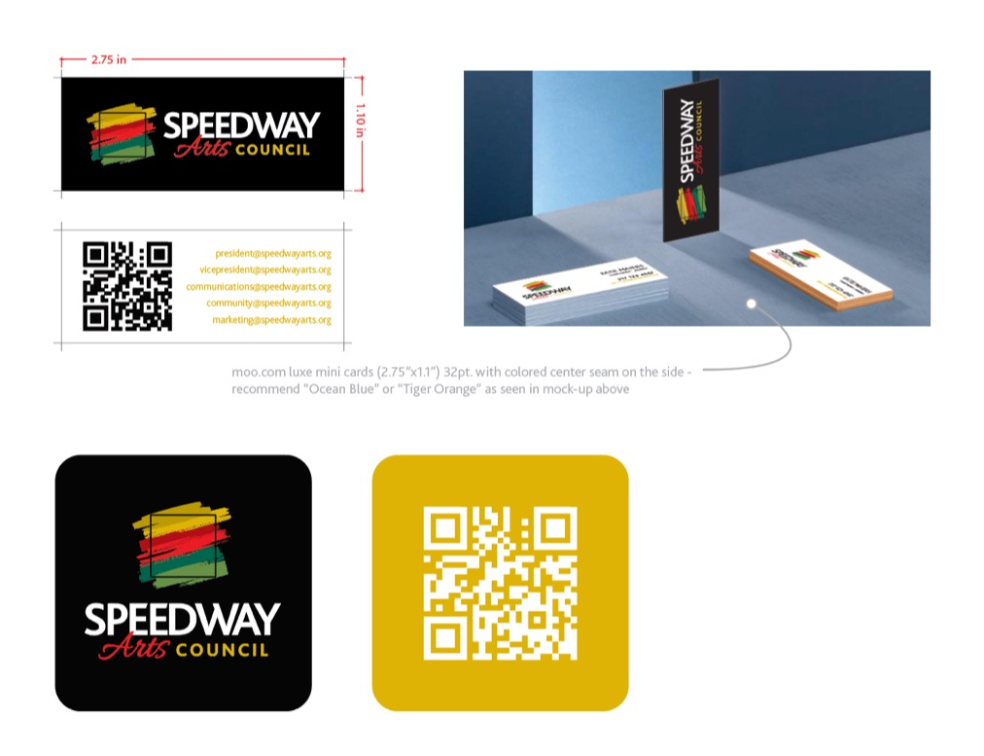
- Ongoing Projects:
  - 1. SMC Mural
    - SRC went over mural proposals: Alex Wakefield was a favorite
    - Next steps: Talk to Tim Gropp, find out about payment structure
    - Proposals from Artists:
      - Travis Neal
      - Jonathan Mummert
      - Michael Martin
      - Alex Wakefiled
  - 2. SMC Lower Level Gallery-
    - Create a museum of Speedway history with items on loan from various residents/businesses
      - Darren Jacks memorabilia
    - Commission artwork from local artists for permanent display
3. May 2022 Pop-Up at Wilcox
Proposal deadline:
4. Christmas pop-up Shop
2 weekends in December 3rd, 4th, 5th, 10th, 11th, 12th and 17th, 18th, 19th
Artists-reach out to may popup artists and their friends (Katie to cc arts council)
- New Projects:
- Alex Wakefield online art sale Nov. 19-21st
  - Needs a space to have his art available for online show: Founders, Foyt Wine Vault, SMC for a couple hours
  - He plans to use a selfie stick and phone to show his work
3. Speedway Art Trail
  - 3. Murals on Main
    - Grant Opportunities
  - 4. Main Street Lighting Project
    - AES Charitable Contributions funding

- Good to the Order: Question about the old 1200 block building
  - More sculpture art
- Announcements:
- Tasks
- Adjournment:
- Executive session
- Next meeting:

