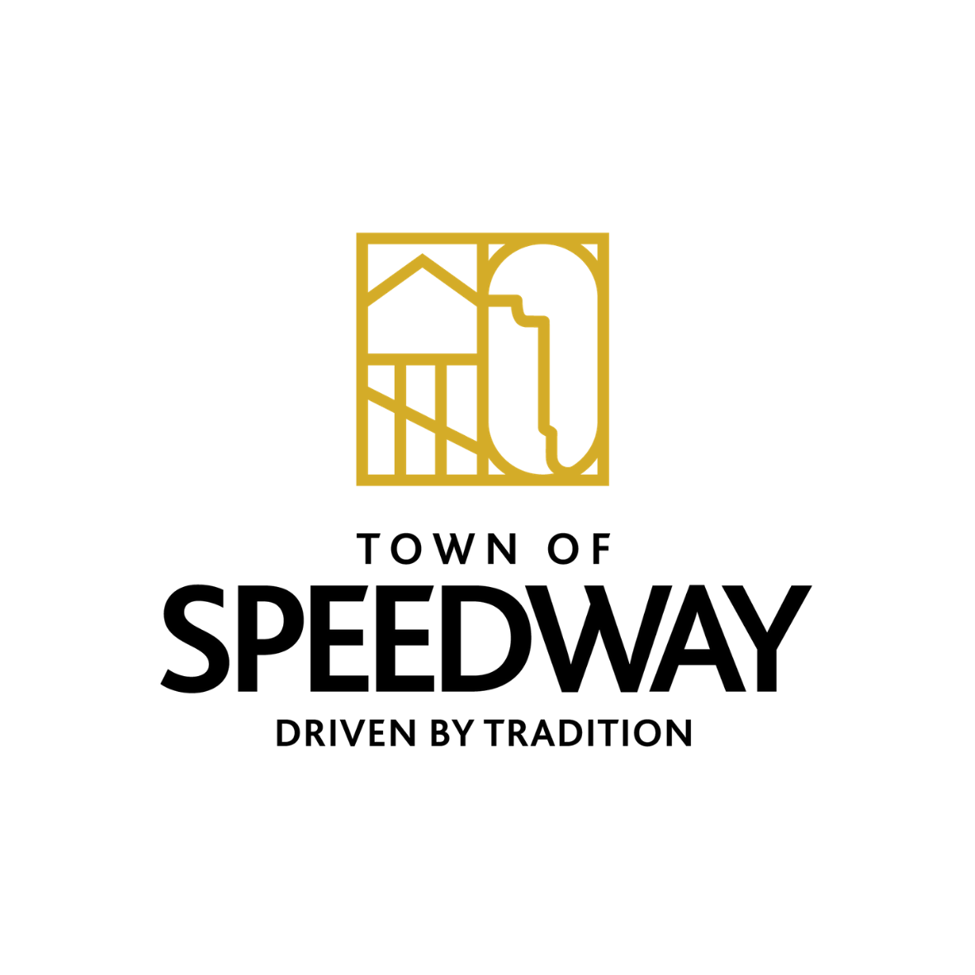
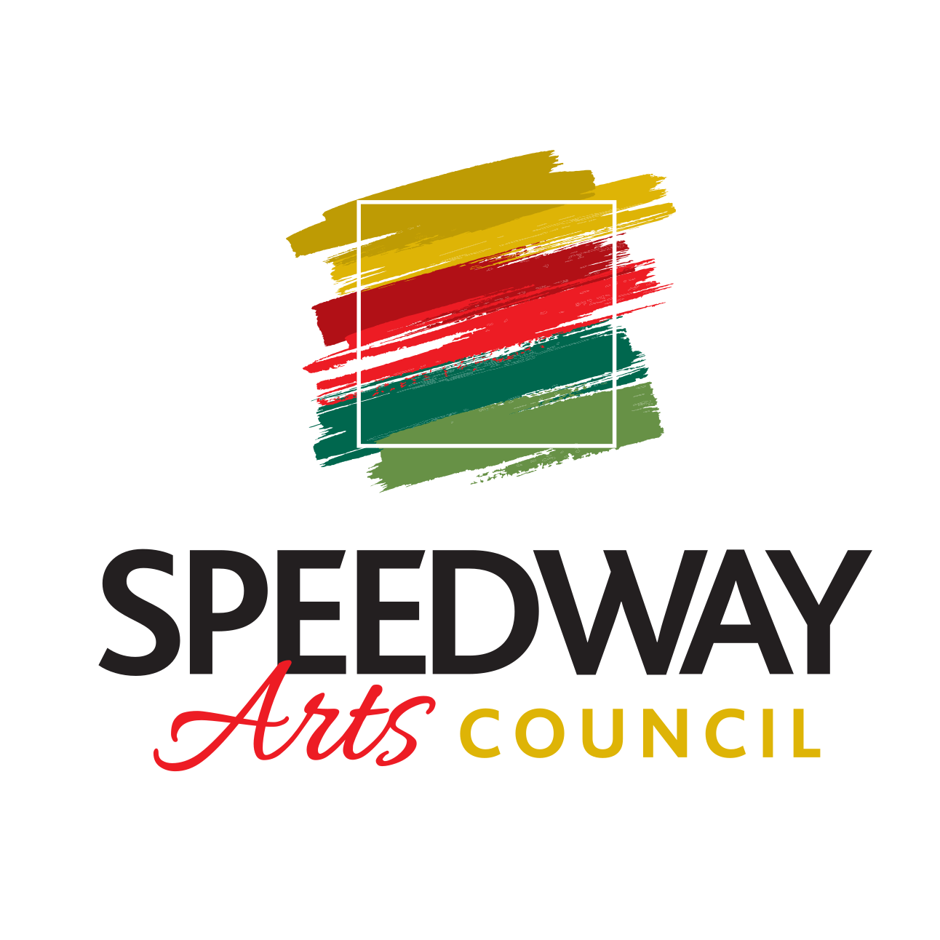
Town of Speedway
Arts Council

Meeting on October 28th, 2021

ATTENDANCE

Board Members: Katie Maiers, Chris Nusbaum, Laura Londry, Bruce Levy, John Miller
Town Officials:
Guests:

MINUTES
- Call Meeting to order:
- Approval of Previous Meeting Minutes (send to Communication Director):
- Reports of Officers:
  - President- Katie Maiers
  - Vice President- Bruce Levy
  - Secretary- Laura Holm
  - Community Liaison- John Miller
  - Communications Director- Chris Nusbaum
  - Guest:
- Reports of Speedway Arts Corporation Non-Profit 501-(c)(3):
  - Financial Report-
    - Ending account balance from:
    - Paypal account-

- Items to vote on:

- Ongoing Projects:
  - 1. SMC Mural
    - Discussion on moving forward
  - 2. SMC Lower Level Gallery-
    - Working with Angie Voorhies and Darren Jacks on racing art and memorabilia to display.
    - Prints from IMS photolab
    - Potential Exhibit Titles:
      - Town of Speedway History and Racing

3. Holiday pop-up Shop
To do list:

4. Alex Wakefield online art sale Nov. 20th at Foyt Wine Vault 12pm-3pm
Volunteers to help film his show/help with setup

- Tasks:

- Executive session date:
- Next meeting: December 21st 6:30pm SMC
- Adjournment:

