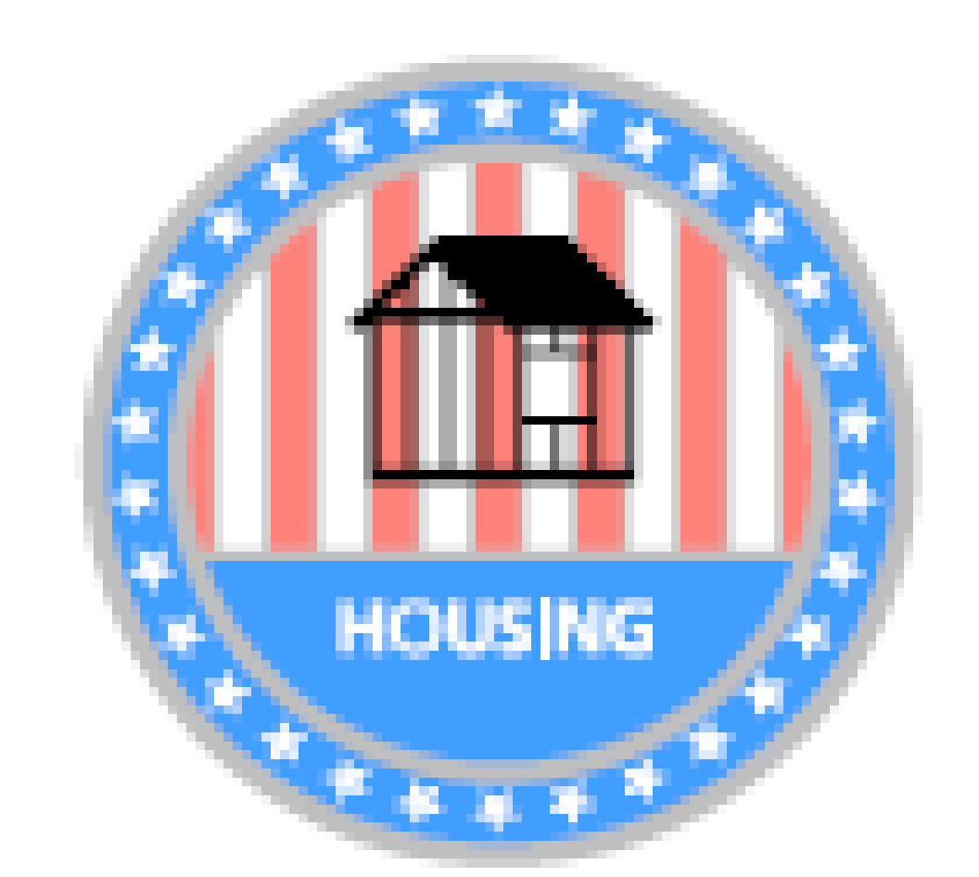
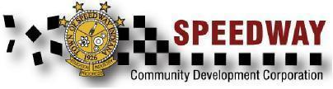

Monthly Meeting Minutes January 19, 2021
Vision - The Speedway Community Development Corporation exists to continue to make Speedway, Indiana a more desirable place to live, work, and visit.
Mission - The Speedway Community Development Corporation aims to continue to make Speedway, Indiana a more desirable place to live, work and visit by enhancing the physical image of the town, supporting economic development efforts and seeking opportunities to improve quality of life for the Speedway community.
CDC Items for Discussion
- Call to Order- 3:00
- Approve Minutes- hold for approval until March meeting and all members can review.
- Financial Reports (if any)- nothing to report
4. Old Business
- 2021 CDC Goals/Tactic Brainstorm (ongoing)
  - Increase community awareness and participation in boards and commissions
    - Create inventory of boards and commissions’ objectives and activities
      - John reviewing objective with Gary Raikes to understand the need/vacancies
      - Request a shared directory of what other boards/commissions are working on
  - Encourage Speedway residents to invest in their homes
    - Permitting process evaluation
      - Refine permitting research project scope and deliverables
        - Holding off on further progress until March
    - Optimize visitor related economic impact
  - Continually strive to improve Speedway town image
    - Gateway project
    - Main Street Rain Gardens

5. New Business
- New Goals/Tactics
  - Other Main Street improvements
  - Cunningham & Crawfordsville intersection concern
- New Officer Election Process on hold
- New CDC members on hold

Other Items / Public Comments

Meeting adjourned at 4:10pm.

CDC Attendance: ___X__ Maggie Bishop ____X_ Adam Gonzalez __X___ John Reller

