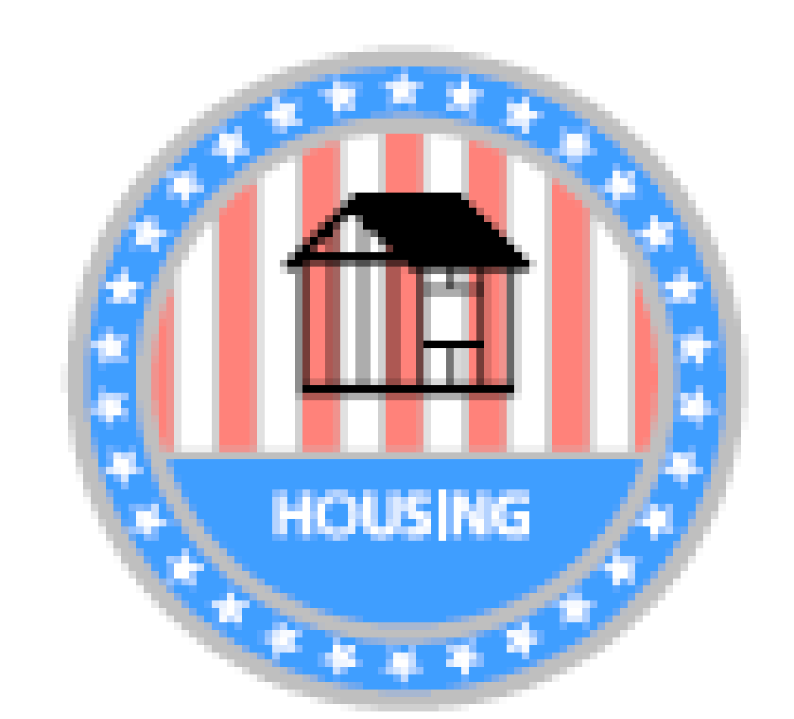

Monthly Meeting MINUTES June 16, 2020

CDC Items for Discussion

- Call to Order- 5:45. Maggie Bishop, Carlos May, David Lang, Adam Gonzales, and John Reller in attendance.

- Introductions & New Board Member- Carlos May

- Approve Agenda/Minutes- Minutes from May meeting to be approved at next meeting.

- Financial Report - Dave Lang- 2 outstanding low interest loans. One should have been paid in full on 5/10, the other is a sewer line replacement being paid monthly.

- Flag Project Update

- Revisiting Project Ideas
  - Updated Carlos on Gateway Project, Permitting process, and Egress window loan programs. Also discussed SHAC relationship to CDC and where we are headed in the future. Carlos will share the council’s vision with us in hopes that we can brainstorm for “what’s next” in our July meeting.

- New Project Ideas- these items were not explicitly discussed in the meeting.
  - Community Gardens
  - Tour of homes

- Meeting adjourned at 6:51

SHAC Items for Discussion

- Review application/volunteer interest
- Select new date for Home Helpers
  - Early Aug. or Sept. 26th? (Indy Do-Day)
- Additional SHAC project ideas

Other Items / Public Comments
CDC Attendance:
__X__ Maggie Bishop __X___ Adam Gonzalez ___X__David Lang
__X___Carlos May __X___ John Reller

SHAC Attendance:
______Vincent Ash _____Shelby Chaplin __X___Mike Hitch
__X____Charlie Maiers _____Chris Manifold _____Austin Templin

