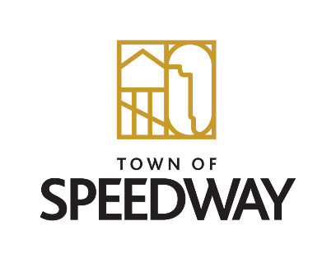

**Centennial Planning Committee - Documentation**

**Meeting Minutes – September 20, 2023   5:00 – 7:00 pm**

Attendance:  Jay, Austin, Gillian, & Cheryl

1. Oral History – possibly setup days for individuals to come in and record their stories
   1. Allow feedback after editing
   2. Possibly use CATV for audio and video options
2. Time Capsule – where will be the new location (possibly new town hall)
   1. Will need a plaque
   2. What to put in it?
      1. Treasury Bond
      2. Photos (how to make them last)
      3. Need to ask public for what should go inside
3. Blue book – Talk to Brock about historical society needs
   1. Ensure they have the right tools
4. Gillian is going to draft a letter to the schools super
5. Recruiting techniques – need to use individual ideas to increase participation
6. Bring History to Speedway
   1. Selfie Spots
   2. Work w/ Indiana Historical Society