Speedway Community Development Corporation
Monthly Meeting Agenda – November 15, 2022 5:30pm
Vision
The Speedway Community Development Corporation exists to make Speedway, Indiana a more desirable place to live, work, and visit.

Mission
The Speedway Community Development Corporation aims to continue to make Speedway, Indiana a more desirable place to live, work and visit by enhancing the physical image of the town, supporting economic development efforts, and seeking opportunities to improve quality of life for the Speedway community.

- Call to Order
- Approve Minutes
- Claims Approval
- Financial Reports
- Old Business
  - Trees
    - Tree Suppliers and Installers
      - Dammanns (James Dammann 317-714-5294)
      - Vibrant
      - Ski Landscape Corporation
        - Quote provided $410 each (2” caliper), price may change
        - Only interested if plant material purchased thru Ski
        - No tree list provided
    - Letter to Homeowners
    - Tree types
      - White Oak, Red Oak, Tulip Poplar, Red Bud, Sugar Maple, Red Maple, Serviceberry
  - Centennial Planning Committee
    - First Meeting Date
    - First Meeting Agenda
    - Boards and Committees Appreciation Video
  - Citizens Academy
    - Outline received, need to readjust for 2023 start
  - Stage
    - Scott Jasek contacted in July
    - Title lost
    - Currently stored at wastewater treatment plant
- New Business
  - FY2023 Objectives
  - Steering Committee Update
  - Open
- Misc
  - Town website states CDC has open position in 2023
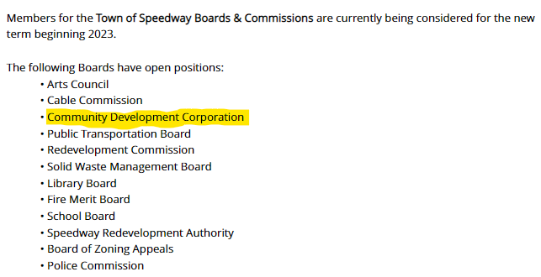

CDC Attendance:
_____ John Reller (Treasurer)
_____ Charlie Maier (President)
_____ Austin Templin (Secretary)
_____ Grant Kleinhenz (Town Manager)
_____ Christine Meador (RDC Appointee)

