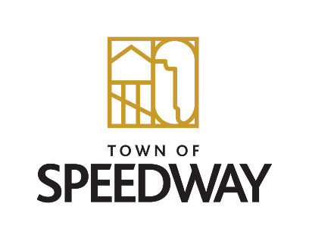
Community Development Corporation Announces
Centennial Planning Committee Formation

The Town of Speedway’s Community Development Corporation announces a new committee designed to plan events and celebrations for the 100-year anniversary of the incorporation of the Town of Speedway in 1926.

The Centennial Planning Committee will create, design, produce, and promote the events and activities which are intended to celebrate the 100th Anniversary of the incorporation of the town of Speedway in 2026. This committee can only be successful with volunteers who are passionate about the town, and therefore we are asking for your help. Each of the respective groups who are receiving this letter have been identified as important contributors. While we would appreciate at least one member from each of the groups, anyone interested is welcome.

Centennial Planning Committee will have a kickoff meeting at 5:30 pm on March 16, 2023, at the Municipal Center.

Groups included for participation:
- Speedway Town Council
- Speedway Town Management
- Historical Society
- Speedway Schools
- Speedway Chamber of Commerce
- Speedway Lions Club
- Indianapolis Motor Speedway
- Parks & Recreation Board
- Speedway Trails
- Arts Advisory Council
- Speedway Library
- Old Speedway Neighborhood Association

