Notice Date: March 10, 2023

SPEEDWAY ECONOMIC DEVELOPMENT COMMISSION

Meeting: Date: Time:
Regular Meeting
Monday, March 13, 2023
5:00 p.m.

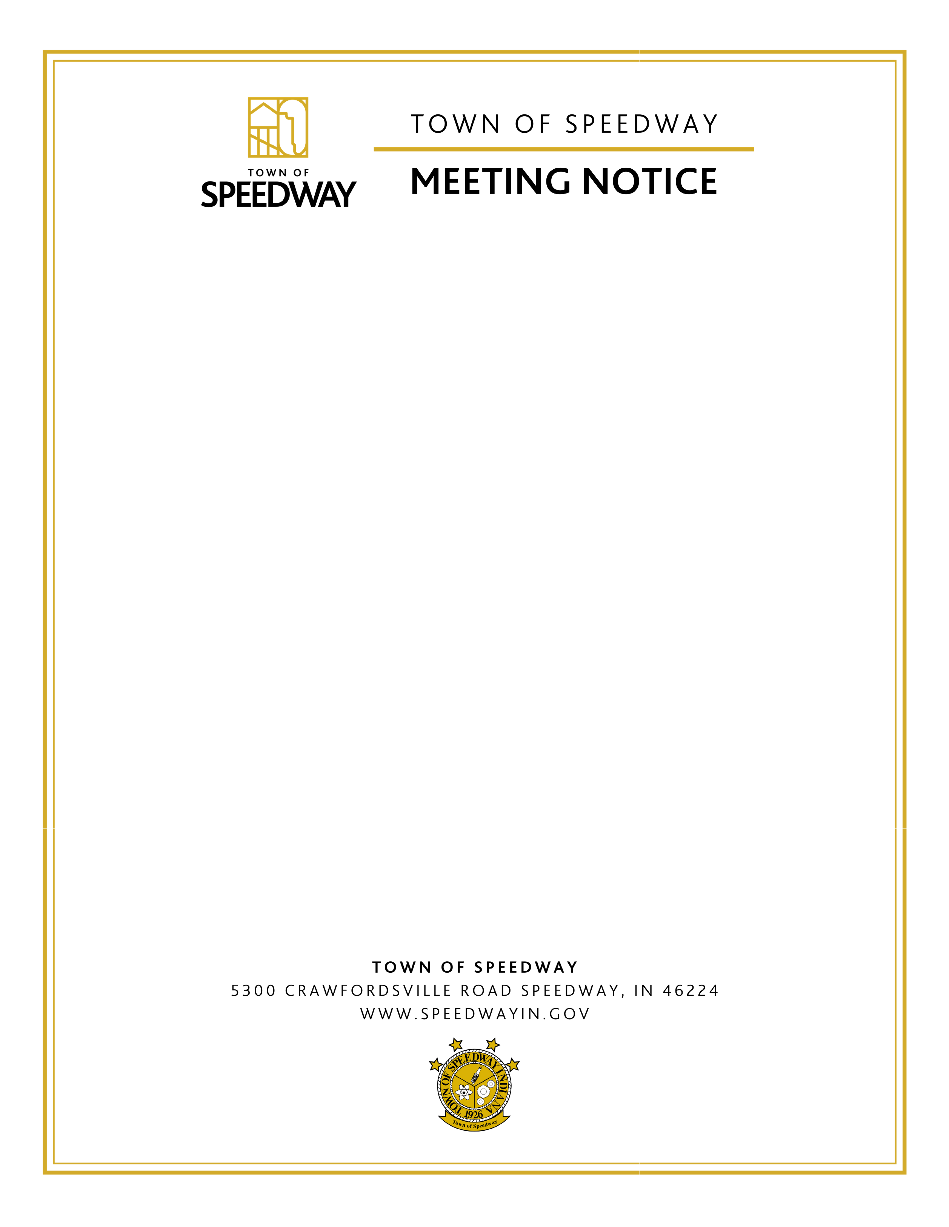
Location: Speedway Municipal Center
Allison Conference Room
5300 Crawfordsville Road

